**NAME:Shreyash Panage**

**ROLL NO:58**

**BRANCH:AIDS**

**Practical No. 3**

**Aim: Perform select queries using predicates**

**Q.**1 **Create LOCATION Table with columns Location_Id, Regional_Group.**

**Constraints on LOCATION table: Location_Id Primary Key.**

**SOLN:-**

CREATE TABLE LOCATION (

Location_Id INT PRIMARY KEY,

Regional_Group VARCHAR(255)

);

**2. Insert the following records into the table LOCATION:**

**LOCATION_ID REGIONAL_GROUP**

**------------- ------------------------------**

**122 NEW YORK**

**123 DALLAS**

**124 CHICAGO**

**167 BOSTON**

**SOLN:-**

INSERT INTO LOCATION (Location_Id, Regional_Group)

VALUES (122, 'NEW YORK'), (123, 'DALLAS'), (124, 'CHICAGO'),

(167, 'BOSTON');

Q**. 3 Create DEPARTMENT Table with columns Department_Id, Name, Location_ID.**

**Constraints on DEPARTMENT table: Department_Id Primary Key, Location_Id references LOCATION table.**

**SOLN:-**

CREATE TABLE DEPARTMENT (

Department_Id INT PRIMARY KEY, Name VARCHAR(255), Location_Id INT,

FOREIGN KEY (Location_Id) REFERENCES LOCATION(Location_Id));

**Q. 4 Insert the following records into DEPARTMENT table:**

**DEPRATMEMT_ID NAME LOCATION_ID**

**------------------------ --------------------- ---------------------**

**10 ACCOUNTING 122**

**20 RESEARCH 124**

**30 SALES 123**

**40 OPERATIONS 167**

**SOLN:-**

INSERT INTO DEPARTMENT (DEPARTMENT_ID, NAME, LOCATION_ID)

VALUES

(10, 'ACCOUNTING', 122),

(20, 'RESEARCH', 124),

(30, 'SALES', 123),

(40, 'OPERATIONS', 167);

Q. 5 Create JOB Table with columns Job_Id, Funcation.

Constraints on JOB table: Job_ID Primary Key.

**SOLN:-**

CREATE TABLE JOB (

Job_Id INT PRIMARY KEY,

FUNC VARCHAR(50)**);**

**Q. 6 Insert the following records into JOB table:**

**JOB_ID FUNCTION**

**------------------ -------------------**

**667 CLERK**

**668 STAFF**

**669 ANALYST**

**670 SALESPERSON**

**671 MANAGER**

**672 PRESIDENT**

**SOLN:-**

INSERT INTO JOB (JOB_ID, FUNC)

VALUES

(667, 'CLERK'),(668, 'STAFF'),(669, 'ANALYST'), (670, 'SALESPERSON'), (671, 'MANAGER'),

(672, 'PRESIDENT');

**Q. 7 Create EMPLOYEE Table with columns Employee_Id, Last_Name,First_Name, Middle_Name, Job_Id, Manager_Id, Hire_Date, Salary, Comm, Department_ID.**

**Constraints on EMPLOYEE table: Employee_Id Primary Key, Last_Name NotNull, Department_Id references DEPARTMENT table.**

**SOLN:-**

CREATE TABLE EMPLOYEE (

Employee_Id INT PRIMARY KEY, Last_Name VARCHAR(50) NOT NULL,

First_Name VARCHAR(50),Middle_Name VARCHAR(50), Job_Id INT,

Manager_Id INT, Hire_Date DATE, Salary DECIMAL(10,2), Comm DECIMAL(10,2),

Department_Id INT,

FOREIGN KEY (Department_Id) REFERENCES DEPARTMENT (Department_Id)

);

**8. Insert the following records into EMPLOYEE table:**

|  |  |  |  |  |  |  |  |  |  |
| --- | --- | --- | --- | --- | --- | --- | --- | --- | --- |
| Employee_Id | Last_Name | First_Name | Middle_Name | Job_Id | Manager_Id | Hire_Date | Salary | Comm | Department_ID |
| 7369 | SMITH | JOHN | Q | 667 | 7902 | 17-DEC-84 | 800 | NULL | 20 |
| 7499 | ALLEN | KEVIN | J | 670 | 7698 | 20-FEB-85 | 1600 | 300 | 30 |
| 7505 | DOYLE | JEAN | K | 671 | 7839 | 04-APR-85 | 2850 | NULL | 30 |
| 7506 | DENNIS | LYNN | S | 671 | 7839 | 15-MAY-85 | 2750 | NULL | 30 |
| 7507 | BAKER | LESLIE | D | 671 | 7839 | 10-JUN-85 | 2200 | NULL | 40 |
| 7521 | WARK | CYNTHIA | D | 670 | 7698 | 22-FEB-85 | 1250 | 500 | 30 |

**SOLN:-**

INSERT INTO EMPLOYEE (Employee_Id, Last_Name, First_Name, Middle_Name, Job_Id, Manager_Id, Hire_Date, Salary, Comm, Department_Id)

VALUES

(7369, 'SMITH', 'JOHN', 'Q', 667, 7902, TO_DATE('17-DEC-84', 'DD-MON-YY'), 800, NULL, 20),

(7499, 'ALLEN', 'KEVIN', 'J', 670, 7698, TO_DATE('20-FEB-85', 'DD-MON-YY'), 1600, 300, 30),

(7505, 'DOYLE', 'JEAN', 'K', 671, 7839, TO_DATE('04-APR-85', 'DD-MON-YY'), 2850, NULL, 30),

(7506, 'DENNIS', 'LYNN', 'S', 671, 7839, TO_DATE('15-MAY-85', 'DD-MON-YY'), 2750, NULL, 30),

(7507, 'BAKER', 'LESLIE', 'D', 671, 7839, TO_DATE('10-JUN-85', 'DD-MON-YY'), 2200, NULL, 40),

(7521, 'WARK', 'CYNTHIA', 'D', 670, 7698, TO_DATE('22-FEB-85', 'DD-MON-YY'), 1250, 500, 30);

**Perform the following queries on the above tables:**

1. List all job details.

**SELECT * FROM JOB;**

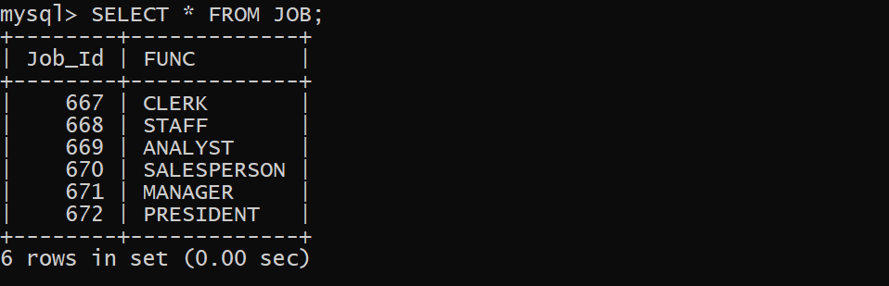

1. List all the locations.

**SELECT * FROM LOCATION;**

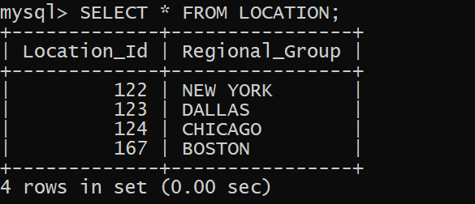

1. List out first name,last_name,salary, commission for all employees.

**SELECT First_Name, Last_Name, Salary, Comm FROM EMPLOYEE;**

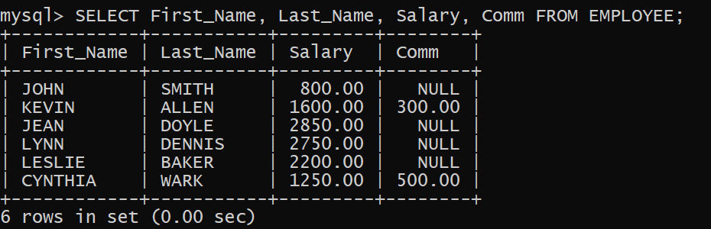

1. List out employee_id,last_name,department_id for all employees and rename employee_id as “ID of the employee”, last_name as “Name of the employee”, department_id as “department ID”.

SELECT Employee_Id , Last_Name , department ID FROM EMPLOYEE;

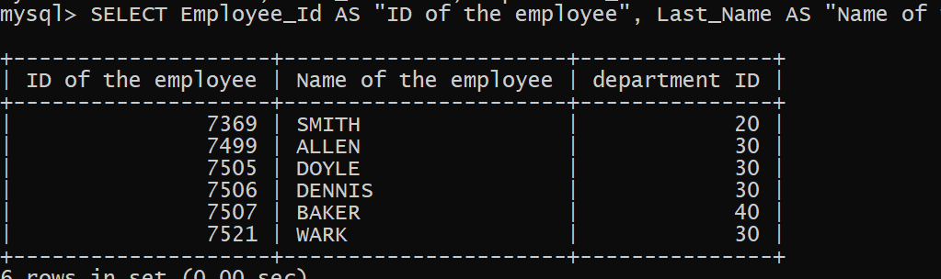

1. List out the employee’s annual salary with their names only.

**SELECT CONCAT(First_Name, ' ', Last_Name) AS "Name", Salary*12 AS "Annual Salary" FROM EMPLOYEE;**

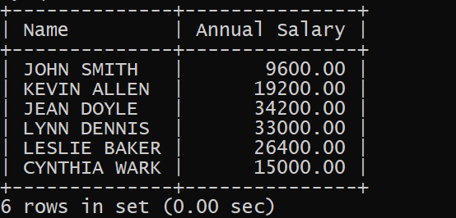

1. List out the employees who are working in department 20.

**SELECT * FROM EMPLOYEE WHERE Department_ID = 20;**



1. List out the employees who are earning salary between 3000 and 4500.

SELECT * FROM EMPLOYEE WHERE Salary BETWEEN 3000 AND 4500;

1. List out the employees who are working in department 10 or 20.

**SELECT * FROM EMPLOYEE WHERE Department_ID IN (10, 20);**

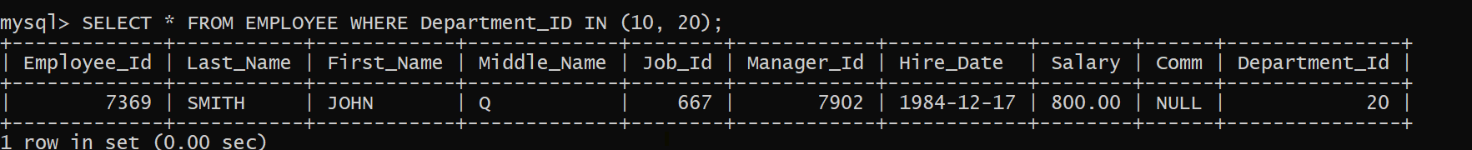

1. List out the employees whose name starts with “S”.

**SELECT * FROM EMPLOYEE WHERE First_Name LIKE 'S%';**



1. List out the employees whose name length is 4 and start with “S”

**SELECT * FROM EMPLOYEE WHERE First_Name LIKE 'S___' AND LENGTH(First_Name) = 4;**



**Conclusion:- we Perform select queries using predicates**